Report

Reports are automatically generated by the **ProDiscover Tool**. When a file of interest is found that can work as an evidence, we can simply add them to the report.

Use the **Add to Report** button.

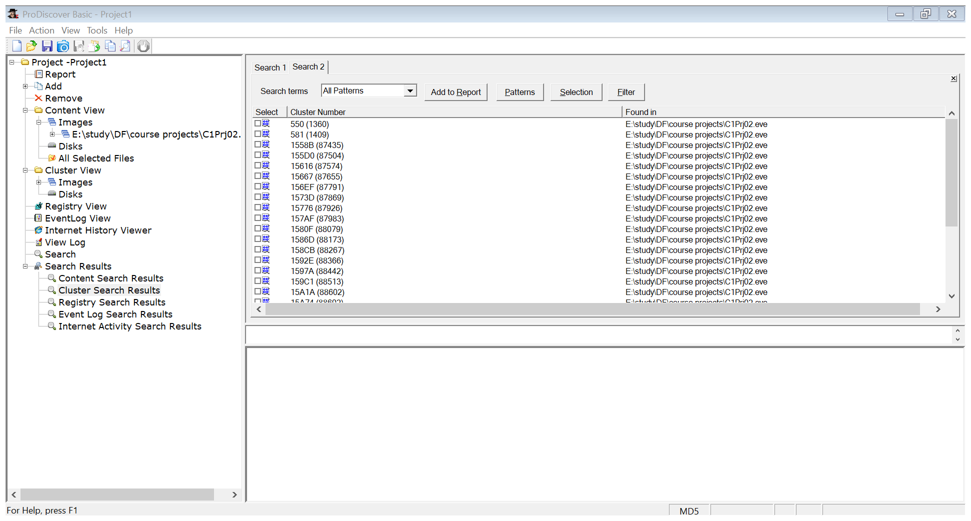

Get the generated report by clicking on the **Report** button.

